A parents guide to… Guided Group Reading (GGR)

Children are taught to read through building simple words using letter sounds (the ‘Read, Write, Inc’ programme) and recognising an increasing range of ‘sight vocabulary’. However, reading for deeper understanding is complex and goes well beyond a child’s ability to build a word through sounds (decoding), recognising and saying the words on the page. There are a range of such ‘higher order’ reading skills, such as inference, deduction and summarising, which children need to develop in order to read successfully for both information and pleasure. This is where ‘GGR’ plays an important role in the teaching of reading at Maes yr Haul Primary School.

Progression of reading strategies
Strategy | Expected Age Range* | Description of Activity
Phonics | Nursery - Year 3 and older where required. | Regular sessions using ‘Read, Write, Inc’ with teachers and support staff. We aim for pupils to ‘complete’ the programme during Years 2 & 3.
Individual Reading | All Ages | Reception – Yr1: Individual reading to a member of staff  Years 2 – 6: Regular independent reading opportunities.
Guided Group Reading (GGR) | Year 1 – Year 6  (Introduced when pupils are ready) | Reading in small groups, silently and aloud, discussing reading and meaning with the teacher. Other groups carry out independent follow-up activities.
Shared Reading | All Ages | Reading from texts on displays, whiteboard, big-books, text books, group books etc with follow-up activities to practice specific reading skills.

* Ages are a general guide – approaches are always tailored to the individual needs of pupils, particularly those who are more able or with additional learning needs.

What is guided group reading?
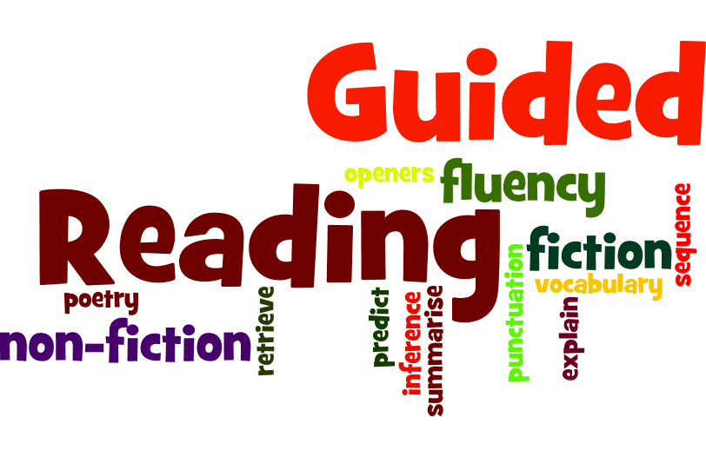
Guided group reading is a teaching technique used to support children to acquire extended reading skills beyond simple ‘decoding’. The session usually lasts about 20-25 minutes. The teacher or LSO works with a small group of pupils with similar reading behaviours who can read, understand and respond to similar levels of texts to support and challenge their reading and understanding. A range of different text-types are used (e.g., poetry, fiction, non-fiction) usually pitched at around a 90-95% accuracy level. Pupils read aloud and are supported to develop silent reading for short periods of time, summarising and explaining what they have read.

What are the aims of GGR?
Sending books home
As children start to bring home books from school, there are still a wide range of skills for children to learn besides reading the print on the page.

In the early stages, ‘Read, Write, Inc’ is used in school as the main scheme to teach reading skills through developing phonic knowledge and decoding skills. The books used in school will be at the edge of pupils’ reading ability. The books we send home however are taken from a range of schemes which have been organised into book bands. These promote using different skills for example, books with words which are decodable and books which rely on sight vocabulary, and will generally be at a slightly easier level for consolidation.
Once the teacher decides that your child is ready, they will move from reading individually each week to reading as part of a guided group reading group. Our aim is for most pupils to begin this at some point during Year 2 although some older pupils will continue to need further support with their individual reading.

Regardless of whether pupils are reading individually or in guided group reading groups, they will continue to take other reading books home, from our book bands and usually progressing to free-reading (‘real books’) in the Upper Juniors.
The ultimate goal of guided group reading is to develop pupils’ ability to read a variety of different texts with ease and deeper understanding. Silent reading helps pupils to process the text more quickly with more attention on meaning which gradually improves as their decoding, recognition and fluency skills grow.

In guided group reading sessions, the teacher will have a focus on specific reading strategies which are shared with the pupils, modelled and practised to help them understand the text.

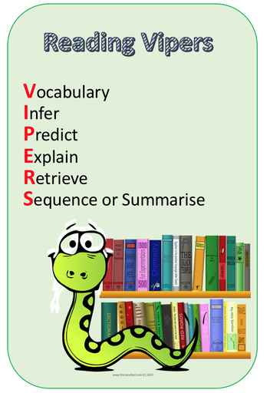
These strategies gradually become more challenging as pupils’ confidence and skill improves.

We incorporate a strategy called ‘VIPERS’ during reading sessions, these are strategies that we encourage the children to use at home too!

Reading diaries
Once children are reading in guided group reading groups, the class teacher will continue to keep detailed records on their reading progress in their class documentation. Those children needing extra support in Years 4 – 6 will still read individually and use reading diaries as a form of communication.

