A community approach to keeping our local community free from litter.

Maes yr Haul Primary School

Bridgend County Borough Council

ECO-SCHOOLS WALES CASE STUDY

Litter picking



What did you do and how did you involve the whole school?

The Eco- committee planned a community litter pick that involved pupils and their families.

They made contact with the local keep Wales tidy team who donated litter picking equipment and bags for the volunteers.

An email was sent out to all the families to invite them to join the event.

All volunteers met in the school grounds straight after school and headed into the lanes and park next to the school.

The event finished at 4.30pm and all bags and equipment were taken back to school.

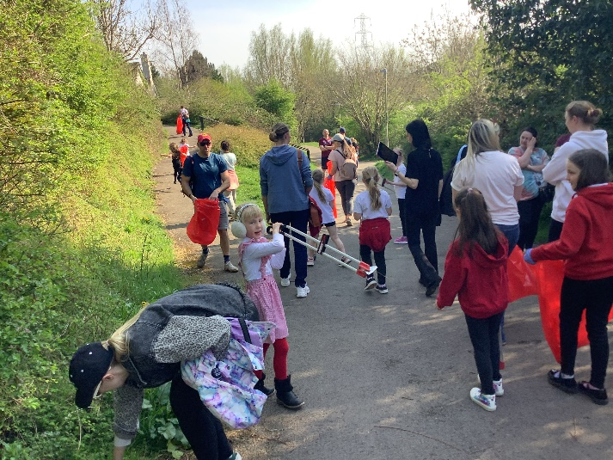

How did you celebrate success and what are your next steps?

The Eco committee shared the success with all the school via Google Classroom and on our school website.

The event was so successful that they are planning to hold another event in the summer term.

QUOTES

*It was a successful event because we collected loads of rubbish. When we got back we realised how much we collected, it was a whopping amount!- Robin L*

*It was a successful event because loads of the community came to support. I think it inspired people and made them aware of how much litter is in the community. I hope we can do it again to help the environment- Alara W*

How has the project impacted on your school and your community?

* During the event the volunteers collected 11 full bags of rubbish in just 45 minutes.
* It has made our community cleaner with less litter.
* It has inspired the pupils who took part as well as others who saw the event happening.

How and why did you decide on this target?

*e.g. Using the Environmental Review, pupil suggestion, competition***.**